Amos
Stephen G. Reynolds, Jr.
Major & Minor Prophets
May 11, 2006
Study Questions

1. Read about Amos in the Davis Bible Dictionary.

2. A citizen of what town?

3. What two jobs did Amos do for work?

4. Who is Amaziah and what did he do to Amos?

5. Look up in the concordance (Strong’s) and give the meaning of Amos’ name.

6. Describe the social conditions during this time?

7. What do you know about the call Amos had?

8. What six foreign nations were judged?

9. Give the two woes.

10. List the five visions.

1. 4.
2. 5.
3.

11. Write an essay on Israel’s restoration 9:11-15.

12. What practical lesson have you learned from this book?

Jonah
Study Questions

1. Give an example of how the history of Jonah is prophetic.
As Jonah was three days and three nights in the whale’s belly; so shall the Son of Man be three days and three nights in the heart of the earth. Jonah in the great fish is a prophetic type of Christ’s death and resurrection.
Matt. 12:40

2. What is the message of the book of Jonah?
Cry against wickedness that God may spare them because God is merciful and salvation is only of the Lord.

3. What happens to the one that walks contrary to God?
If you walk contrary to God, He will walk contrary to you.

4. When must people turn to God with all their heart?
Turn NOW to God with all your heart with fasting and prayer.
(For he saith, I have heard thee in a time accepted, and in the day of salvation have I succoured thee: behold, now is the accepted time; behold, now is the day of salvation.) (2 Cor. 6:2)

5. Describe Jonah’s first commission. 1:2
It was a revelation of God’s Word. Go to Nineveh and cry against it.

6. Favorable __circumstances__ are not necessarily a __sign___

that we are in the __will__ of __God__.

7. Describe Jonah’s chastisement.
The Lord sent a mighty tempest to put Jonah’s ship in Jeopardy. The Lord exposed Jonah as the cause of the evil. Jonah was cast into the sea, the sea ceased raging, and a great fish prepared of God swallowed Jonah. Jonah remained in the belly of this great fish three days and three nights.

8. What did Jonah think of God? 4:2
Jonah knew God was gracious, merciful, slow to anger, and of great kindness.

9. What is the outstanding statement in Jonah’s prayer? 2:4
That he had been cast “out of Thy [God’s] sight.” Even when it was the sinless Son of God on the cross bearing the sins of the world and not His own did the Father turn his back. Sin separates man from God.

10. Notice Jonah’s message of judgment was without mercy, yet the people believed. Compare this with the generations in the disciples’ day and our day.
The disciples preached mercy (For the wages of sin is death; but the gift of God is eternal life through Jesus Christ our Lord.—Rom. 6:23) and preachers with a heart and burden for the people preach the same today. Even though the message has been presented with so much love and mercy people’s hearts are hard and the vast majority refuse the message. (For this people's heart is waxed gross, and their ears are dull of hearing, and their eyes they have closed; lest at any time they should see with their eyes, and hear with their ears, and should understand with their heart, and should be converted, and I should heal them.—Matthew 13:15)

11. What was Jonah’s attitude? 4:1-3
He was full of anger and self-pity.

12. What was the last question the Lord asked?
And should not I spare Nineveh, that great city, wherein are more than sixscore thousand persons that cannot discern between their right hand and their left hand; and also much cattle?—Jonah 4:11

13. Write a short essay on the runaway prophet.
Where can you run to hide from God? Jonah thought maybe the answer was Tarshish. There was a ship ready to sail and everything, but favorable circumstances and “open doors” are not always set by the Lord. The devil will open doors to get you OUT of God’s will. It was no cheap trip, but Jonah paid the fare thereof. There is a great price to pay for stepping out of God’s will. It has been taught us that when you runaway from God or get out of His will, you don’t just step back in. There is fare and Jonah most certainly paid it.

14. Draw three pictures of Jonah’s experience
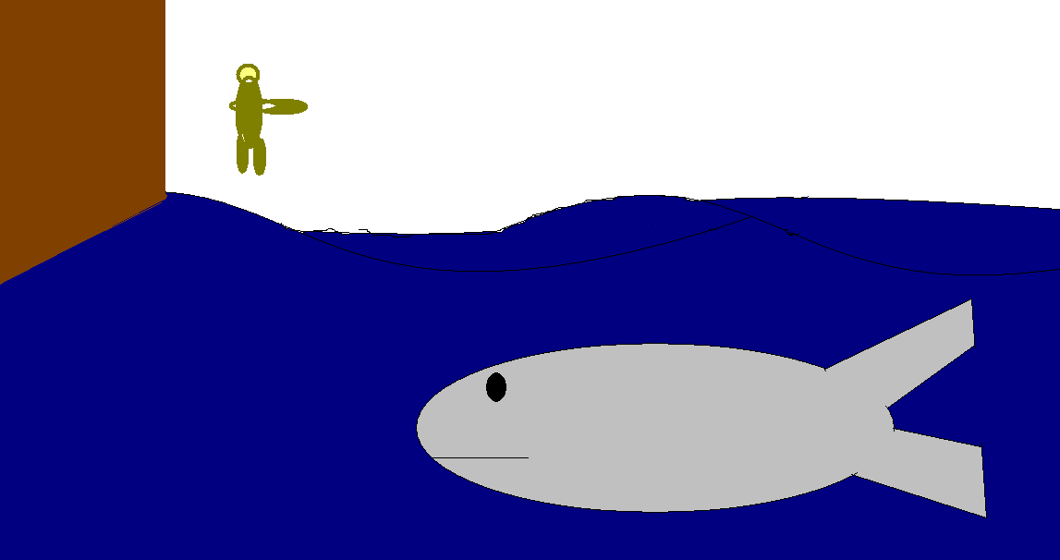
1. Being swallowed 1:17

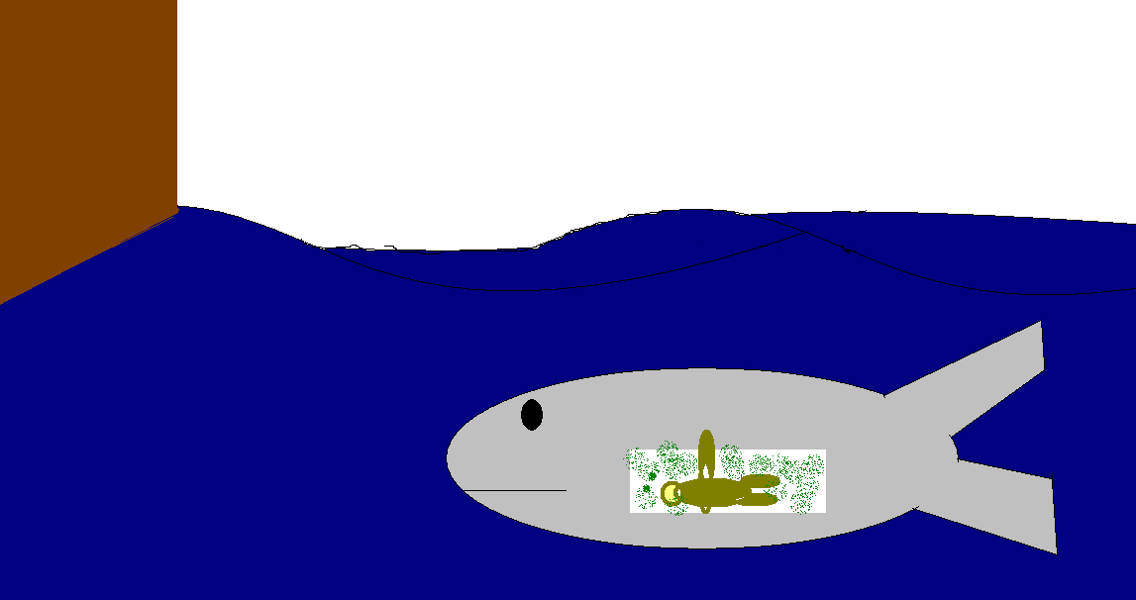
2. Inside view 2:3-6


3. Being released 2:10

15. Describe Jonah’s mixed emotions.
Jonah was upset that God had mercy on such a wicked people and He was full of self-pity. He preferred his own vindication over the sparing of 120,000 Ninevites.

16. What effect does the revelation of God’s Word in Jonah have on your
heart?
It makes me desire a greater burden for the lost. Their judgment is set, but mercy cries for salvation if only someone would echo her call. I must tell them the truth, and not be hindered by a personal agenda like Jonah.

17. What should you do for your city?
My heart should be filled with God’s compassion for my city, and I must do what I can NOW to reach it for Christ before judgment comes.

18. What must fill our hearts?
Our hearts should be filled with God’s compassion.

19. _Judgment_ is sure to _come_ if there is __no__

__true_ __repentance_.

20. God gave Jonah a word 1:1 and He expected implicit obedience.
Compare the storm in Jonah 1:4-16 and Acts 27:9-44.
What is the end results of the two ships? Why?

JONAH 1:4-16
a great wind
mighty tempest
the ship was like to be broken
the mariners were afraid,
A prophet slept on board
rowed hard to bring it to the land; but they could not:
cast him forth into the sea
the sea ceased from her raging.
men feared the LORD

ACTS 27:9-44
Euroclydon, a tempestuous wind
Tossed with a tempest
They lightened the ship
All hope was taken away
The ship was broken
All were safe
There was a prophet on board

Jonah’s Ship escaped safely for the judgment was only on Jonah, but the hinder part of Paul’s ship was destroyed by the waves for it was the ship’s captain who did not hearken to Paul’s message from God at the start. In both cases all were safe and none were lost.

